N2 receive:
Hi (insert first name), it’s (your name). People are always looking for the “Magic Formula” for success with Mary Kay. Actually, it’s making the most of your God-giving talent and ability. I think it takes following three steps: 1.Plan 2.Persist 3.Work. Soar to success by holding skin care classes & facials & placing your first wholesale order! I believe in you.

Stars 1st month A1-A2
Hi (name) it’s (your name). Have you set your sights on Star status this quarter? I hope you've picked out your prize & told everyone about it. Goal is $300/wk. It helps to show guests at your appointments what you are earning! You've got this!

Stars 2nd month A1-A2
Hi (name) it’s (your name). Remember holding appointments is a great way to find new customers, sell product, and finish your STAR! Why not increase the # of connections you make every day? I believe in you! ☺

Stars 3rd month A1-A2
Hi (name) it’s (your name). Qtr. 3 Deadline: 3/15
It’s the final stretch of Star Qtr. -how exciting! Keep tracking, stay committed to your goal & please contact me if you want ideas on finishing. I have belief in you.

PCP Reminder A1-A2-A3
Hi (name) it’s (your name).
Power in Possibility – Spring 2023
Keep your customers beautifully indulged all spring long! I enroll mine for the NEW Spring Look Book, plus Two Free MK product samples. Earn early ordering privileges & share the latest-and-greatest beauty pro tips. Gain perks from enrolling in the Preferred Customer Program. I recommend it highly.
Next deadline: 4/17 (insert image)

$600 Challenge Winners
Hi (name) it’s (your name). Congratulations on investing in your business and achieving the Golden Rules “Walk a Mile in Her Shoes” February Challenge!
You are a blessing in our unit, and I am thankful to be working with you.
(insert congrats image)

New Product Launches
Hi (name) it’s (your name).
This Spring, Let go of what was, embrace what can be!
(insert image)
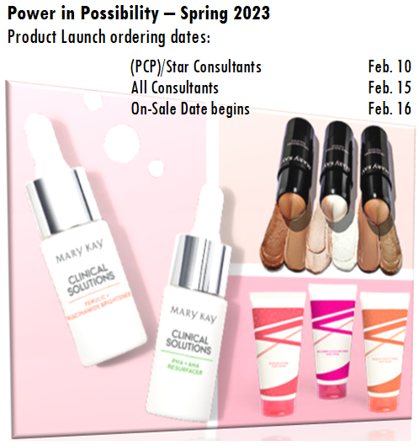

Congrats Star
Hi (name) it’s (your name).
You are working your business, building relationships and selling product!

